A

Project Document on

**Online Cab Booking System**

as a partial fulfilment

for the degree of

**Integrated Masters of Science in Information Technology**

for the year 2019

5th Semester

**BABU MADHAV INSTITUTE OF INFORMATION TECHNOLOGY**



Guided By: Submitted By:

Ms. Kajal Patil. Ms. Nidhi Patel (201706100110067)

Ms. Urvi Patel (201706100110143)

**BABU MADHAV INSTITUTE OF INFORMATION TECHNOLO CERTIFICATE**

This is to certify that **Nidhi Patel (201706100110067), Urvi Patel (201706100110143)** has submitted project entitled **“Online Cab Booking System”** as the partial fulfillment for the award of the degree of Bachelor of Science in Information Technology for 5 Years Integrated M.Sc.(IT) in 2019 – 2020.

**Date: 22nd Nov 2019**

**Place: BMIIT**

**Ms. Kajal Patil Dr. Jitendra Nasriwala**

Guide Programme Coordinator,

Babu Madhav Institute of Information Technology

**Extern Examiner**



**Babu Madhav Institute of Information Technology,**

**Uka Tarsadia University,**

**Bardoli - 394350**

# Acknowledgement

The satisfaction that accompanies the successful completion of this project would be incomplete without mentioning the people who made it possible, without whose constant guidance and encouragement would have made efforts to go in vain. I consider myself privileged to express gratitude and respect towards all those who has guided through the completion of projects.

I convey thanks to my project guide **Ms. Kajal Patil** for providing encouragement, constant support and guidance which was of a great help to complete this project work successfully.

I am grateful to **Dr. Jitendra Nasriwala**, Head of the Department, Babu Madhav Institute of Information Technology, BMIIT for giving us the support and encouragement that was necessary for the completion of this project.

I would like to thank all the faculty members for their patience, understanding and guidance that gave me strength and will power to work through the long tedious hours for developing a project and preparing the report.

Last but not the least, I would also like to thank my colleagues, who give their ideas helped me a lot to improve my project.

**Nidhi Patel (201706100110067)**

**Urvi Patel (201706100110143)**

**Table of Content**

|  |  |  |  |  |
| --- | --- | --- | --- | --- |
| **Chapters** | **Particulars** | | | **Page no.** |
| **1** | **Introduction** | | |  |
| 1.1 | Project Definition | | 5 |
|  |  | |  |
|  | | | | |
| **2** | **Proposed System** | | | 6 |
| 2.1 | Purpose | |  |
| 2.2 | Scope | |  |
|  | | | | |
| **3** | **Software Development Platform** | | |  |
| 3.1 | Technology Used | | 7 |
|  | | | | |
| **4** | **System Analysis** | | | 8 |
| 4.1 | Identification of need | |  |
| 4.2 | Functional Requirement | |  |
| 4.3 | Non-functional Requirement | |  |
| 4.4 | Modules | |  |
| 4.5 | User Characteristics | |  |
|  | | | | |
| **5** | **UML Diagrams** | | | 15 |
| 5.1 | Use case Diagram | |  |
| 5.2 | Activity Diagram | |  |
|  | | | | |
| **6** | **System Design** | | | 23 |
| 6.1 | Database Design | |  |
| 6.1.1 | Data Dictionary |  |
| 6.2 | Interface Design | |  |
| 6.3 | Report Design | |  |
|  | | | | |
| **7** | **System Implementation** | | | 30 |
| 7.1 | Screenshots | |  |
|  | | | | |
| **8** | **Testing** | | | 37 |
| 8.1 | Test Cases | |  |
|  | | | | |
| **9** | **Future Enhancement** | | | 40 |
|  |  | | |  |
|  |  | | |  |

# Chapter 1: Introduction

# 1.1 project Definition

The Online Cab Booking System will help the user to book a cab in which customer can book based on category, price and place.

The system is made for the transportation from one location to another location. User can register itself and can use the facility of booking cab as per its choice from anytime and anywhere.

The Customer can book the cab from the system and the assigned cab driver can view the required details of customer and can finish allocated task with safe ride.

The system administrator can perform the various tasks like insertion, updation and deletion of driver, cab, city, rates and offer. It can also view the details of booking and can also generate the report.

# Chapter 2: Proposed System

# 2.1 Purpose:

The purpose of the project is to develop a general-purpose e-booking business where cab can be booked from the comfort of home through the internet.

# Scope

The system is only for Gujarat cities which are Vapi, Valsad, Navsari, Vyara, Bardoli, Surat, Bharuch and Vadodara. And the city cab booking is only provided for Surat city. It will be available only to the registered user.

# Chapter 3: Software Development Platform

# 3.1 Technology Used

|  |  |
| --- | --- |
| Type | Web Based Application |
| Front-End | ASP.Net with C# |
| Back-End | SQL Server Management Studio 2008 |
| Operating System | Windows |
| Tools | Umlet (for diagrams) |

3.2 Hardware Requirements

**Required Hardware:**

* An x64-capable processor:

The 64-bit version of Windows is also known as the “x64” version of Windows. 64-bit versions have a number of useful security features that 32-bit versions of Windows just don’t. For example, an expanded address space allows Address Space Layout Randomization (ASLR) to better protect against attacks on programs.

* 2 GB or more of RAM:

The more Ram your system has, the more programs it can handle simultaneously

* A monitor with a resolution of 1024 × 768:

A display capable of 1,024 pixels in width and 768 pixels in height.

# Chapter 4: System Analysis

# 4.1 Identification of need

* Customer can book cab without going out.
* Some Areas are not covered by bus so cab can go there.
* To expand Cab Business in market.

## 4.2 Functional Requirement:

● Registration:

The system shall be able to register all the customers. The registration of drivers can be done by admin. The information will be stored in the database.

● Log in:

The system shall be able to allow the customers, drivers and admin to login into the system, by checking the authentication on the basis of email id and password entered by them. After 3 unsuccessful attempts, the user will be blocked.

● *Forgot Password:*

Users can change their password, if they forget. To set new password system will be send old password to user's Email ID or mobile number. After that, the user can set new password.

● *Change Password:*

Users can change their password where they need to enter their old password and if it matches with the current password, then the new password can be set.

● *Edit Profile:*

Customers can update their Name, Contact number, Address and Email id if they want to. The drivers will only be able to view their ID, Name, Age, Contact number, Address and Email id. Admin can update the account of drivers.

● Cab booking:

Customers can enter the required details for booking and by selecting cab type as their requirement Cab can be booked. The driver will get task and cab status will be busy until driver change it.

● Feedback:

A feedback form from customer will be get and driver and admin can view the system feedback.

● Generate bill:

After the customer provide the booking data system will calculate the bill amount and will generate the bill.

● Offers:

Customer will be provided by the various offers in booking cab with applied conditions.it will be for limited period of time.

● Generate report:

System will generate report. This functionality will be done by admin.

## 4.3 Non-Functional Requirement:

## Responsive:

## By using bootstrap, the system will be device friendly.

## Security:

## By applying MD5

## 4.4 Modules :

## Login

## Manage Booking

## Manage Offers

## Manage Drivers

## Manage Feedback

## Manage Profile

## Manage Rates

## Generate Report

## 

## 4.5 User Characteristics:

Users:

1. **Customer**

* Customer can register into the system.
* Customer can login into the system.
* Customer can book a cab.
* Customer can view and apply offers.
* Customer can manage it’s profile.
* Customer can view bill.
* Customer can give feedback.

1. **Admin**

* Admin can login into the system.
* Admin can view details of registered customers.
* Admin can register car details.
* Admin can register driver details.
* Admin can manage rates.
* Admin can manage offers.
* Admin can generate report.
* Admin can send message to particular driver or customer.
* Admin can view customer feedback.

1. **Driver**

* Driver can login into the system.
* Driver can manage its profile.
* Driver can manage its car and its details.
* Driver can update its location and its status.
* Driver can view allocated customer’s required details while booking.
* Driver can view customer's feedback.
* Driver can view its inbox messages sent by admin.

## Chapter 5 : UML Diagrams

## 5.1 Use Case Diagram :

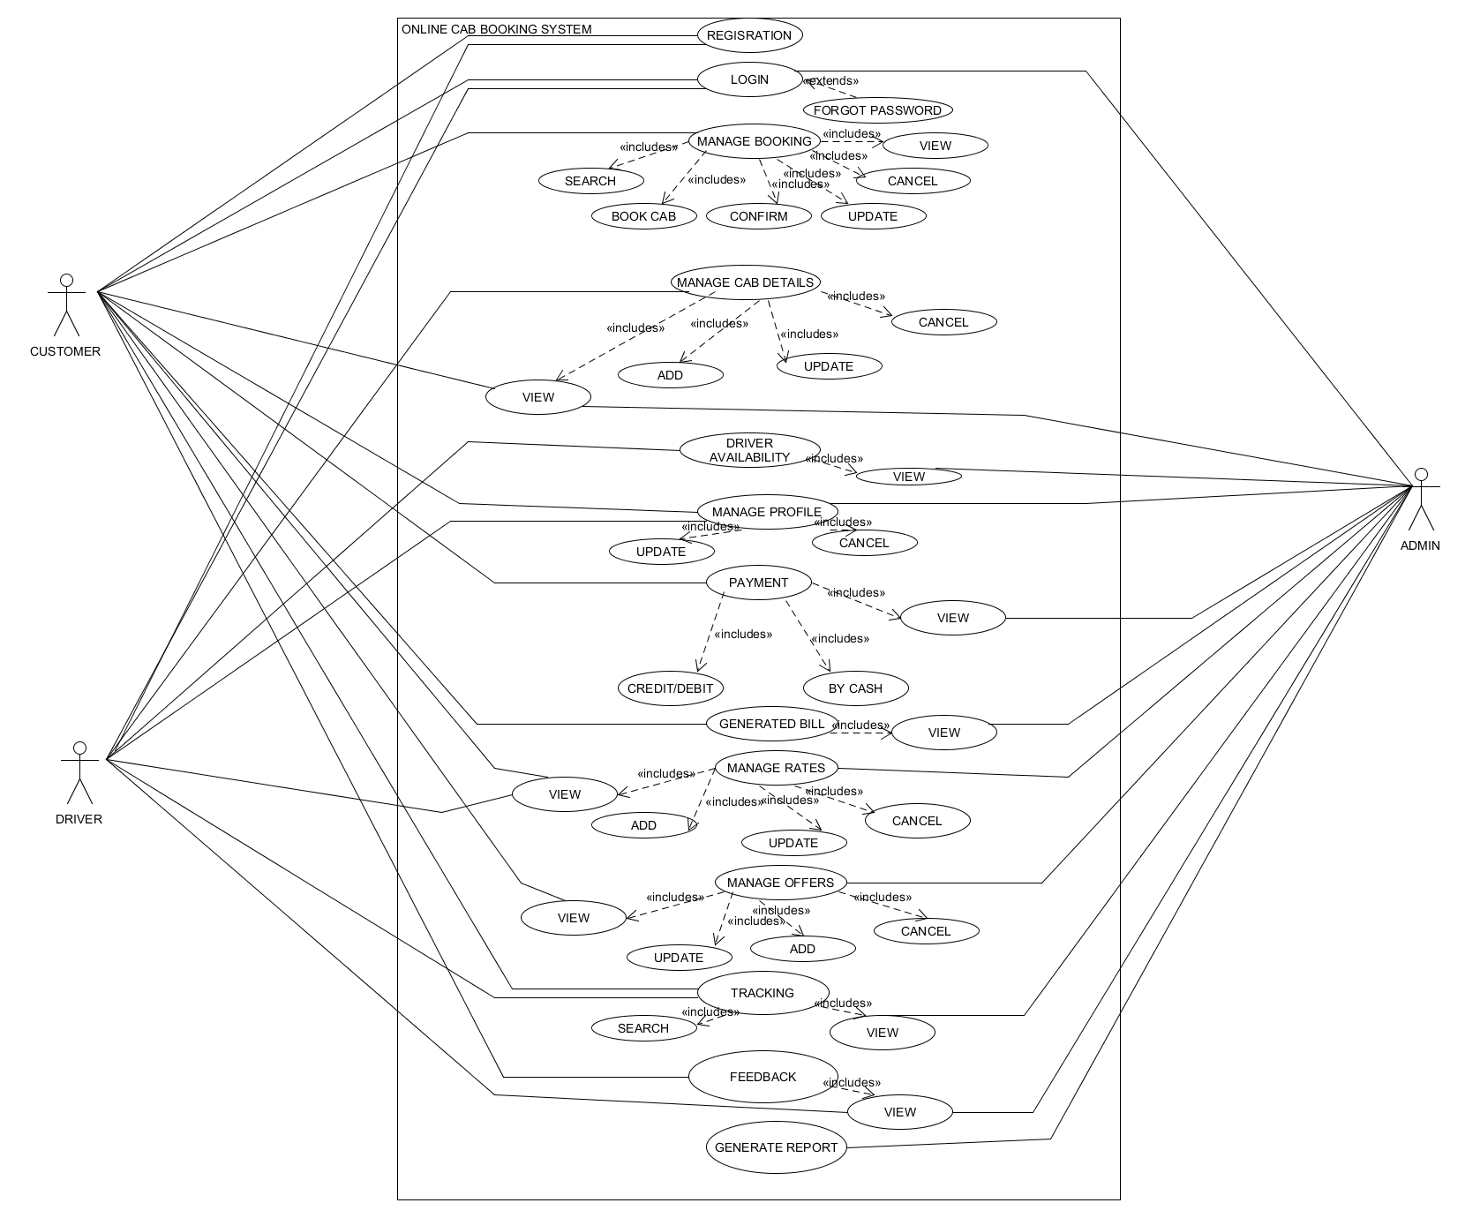

|  |
| --- |
| **Introduction**  The use case document depicts the steps that must be followed for Manage Profile. |
| **Actors**  Customers  Drivers  Admin |
| **Pre-condition**  Contestants, judges and the admin must log into the system to manage their profiles. |
| **Post-condition**  If the use case is successful, the user will be redirected to the same page with updated records. |
| **Event Flow**  ***Basic Flow:*** Users will be on the same page with updated records. |
| **Alternative Flow:** 1. Invalid credentials  If the data being inserted are invalid, the user will be prompted by an error message of invalid values. |
| **Special Requirement**  None |
| **Associated Use Case**  Login |

|  |
| --- |
| **Introduction**  The use case document depicts the steps that must be followed for Cab Booking. |
| **Actors**  Customers  Drivers  Admin |
| **Pre-condition**  1. Customers, drivers and the admin must log into the system.  2. customer must have entered the required details for booking. |
| **Post-condition**  If the use case is successful, the cab status and driver status will be changed to busy and booking will be confirmed. |
| **Event Flow**  ***Basic Flow:*** driver will change cab status after completion of task  and admin will also be able to view the results. |
| **Alternative Flow:** 1. Invalid credentials  If the data being inserted are invalid, the user will be prompted by an error message of invalid values. And if the selected cab type is not available customer will be promoted by error message. |
| **Special Requirement**  None |
| **Associated Use Case**  Login  Manage Booking |

## 5.2 Activity Diagrams :

## Activity Diagram for Manage Registration:

## C:\Users\DELL\Downloads\attachments\Registration.jpg

1. **Activity Diagram for Manage Login :**

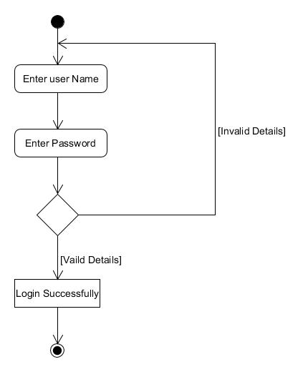

1. **Activity Diagram for Manage Booking:**

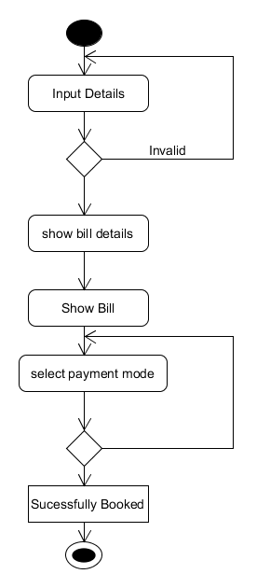

1. **Activity Diagram for Manage Cab Details:**

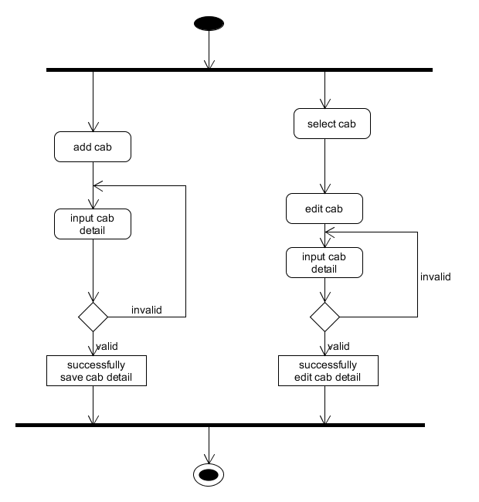

1. **Activity Diagram for Manage Offers:**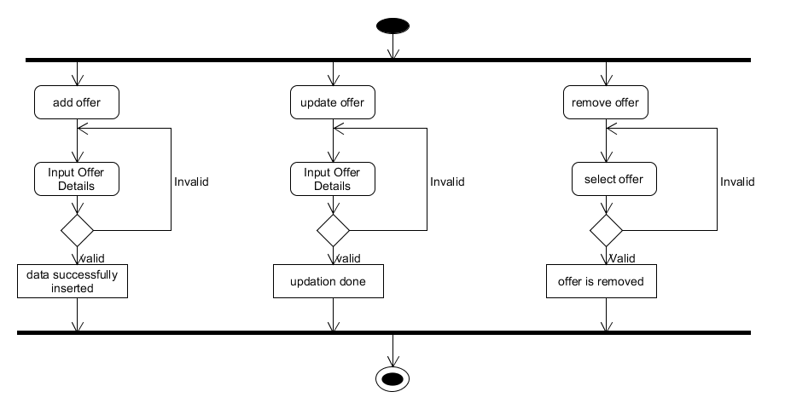
2. **Activity Diagram for Manage Payment:**

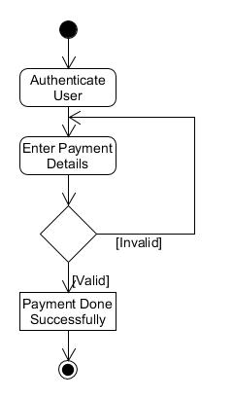

## Chapter 6 : System Design

## 6.1 Data Dictionary

**1.TblCustomerMaster**

|  |  |  |  |  |
| --- | --- | --- | --- | --- |
| **Field name** | **Field Type** | **Field size** | **constraints** | **description** |
| CustomerId | Integer | - | primary key, auto increment | It is uniquely identifies each registered user |
| CustomerName | Varchar | 20 | not null | It specifies name of registered user |
| CustomerAddress | Varchar | 50 | not null | It specifies address of registered user |
| CustomerCono | Varchar | 10 | not null, unique key | It specifies unique contact number of registered User. |
| EmailId | Varchar | 25 | not null, unique key | It specifies unique email id of registered user. |
| Password | Varchar | 25 | not null | It identifies the password for authentication of registered user. |
| Type | Varchar | 8 | not null | It defines the role of user. |
| Status | Varchar | 10 | not null | It identifies the states of registered user account. |

**2.TblDriverMaster**

|  |  |  |  |  |
| --- | --- | --- | --- | --- |
| **Field name** | **Field Type** | **Field size** | **constraints** | **description** |
| DriverId | Integer | - | primary key, auto increment | It is uniquely identifies each registered user |
| DriverName | Varchar | 20 | not null | It specifies name of registered user |
| DriverAddress | Varchar | 50 | not null | It specifies address of registered user |
| EmailId | Varchar | 25 | not null, unique key | It specifies unique email id of registered user. |
| Password | Varchar | 10 | not null | It identifies the password for authentication of registered user. |
| DriverCono | Varchar | 20 | not null, unique key | It specifies unique contact number of registered user |
| Type | Varchar | 10 | not null | It defines the role of user. |
| DriverImage | Varchar | 100 | not null | It identifies the image of registered user. |
| Status | Varchar | 10 | not null | It identifies the states of registered user account. |

**3.TblCabMaster**

|  |  |  |  |  |
| --- | --- | --- | --- | --- |
| **Field name** | **Field Type** | **Field size** | **constraints** | **description** |
| CabId | Integer | - | primary key, auto increment | It is uniquely identifies each registered cab |
| CabName | Varchar | 30 | not null | It specifies name of registered cab |
| CabType | Varchar | 10 | not null | It specifies the type of registered cab. |
| CabRTOno | Varchar | 10 | not null , unique key | It specifies unique RTO number of registered cab |
| Status | Varchar | 10 | not null | It specifies the status of cab. |

**4.TblCityMaster**

|  |  |  |  |  |
| --- | --- | --- | --- | --- |
| **Field name** | **Field Type** | **Field size** | **constraints** | **description** |
| CityId | Integer | - | primary key, auto increment | It is uniquely identifies each registered city |
| CityName | Varchar | 50 | not null | It specifies name of registered city |
| Latitude | numeric | (10,5) | not null | It specifies latitude of particular city. |
| Longitude | numeric | (10,5) | not null | It specifies longitude of particular city. |

**5.TblAreaMaster**

|  |  |  |  |  |
| --- | --- | --- | --- | --- |
| **Field name** | **Field Type** | **Field size** | **constraints** | **description** |
| AreaId | Integer | - | primary key, auto increment | It is uniquely identifies each registered area of city |
| AreaName | Varchar | 50 | not null | It specifies name of registered area of city |
| Latitude | numeric | (10,5) | not null | It specifies latitude of particular city. |
| Longitude | numeric | (10,5) | not null | It specifies longitude of particular city. |

**6.TblOffers**

|  |  |  |  |  |
| --- | --- | --- | --- | --- |
| **Field name** | **Field Type** | **Field size** | **constraints** | **description** |
| OfferId | Integer | - | primary key, auto increment | It is uniquely identifies each offer no. |
| OfferName | Varchar | 50 | not null | It specifies name of offer. |
| StartingDate | date | - | not null | It specifies the starting date of offer |
| EndingDate | date | - | not null | It specifies the ending date of offer |
| Promocode | Varchar | 8 | not null , unique key | It specifies the unique promocode of offer |
| Description | Varchar | 50 | not null | It specifies the offer in detail. |

**7.TblPayment**

|  |  |  |  |  |
| --- | --- | --- | --- | --- |
| **Field name** | **Field Type** | **Field size** | **constraints** | **description** |
| PaymentId | Integer | - | primary key , auto increment | It specifies the identity of payment no. |
| PaymentType | Varchar | 10 | not null | If specifies the name of payment type. |

**8.TblBillDetails**

|  |  |  |  |  |
| --- | --- | --- | --- | --- |
| **Field name** | **Field Type** | **Field size** | **constraints** | **description** |
| BillId | Integer | - | primary key , auto increment | It specifies the identity of bill no. |
| TotalKm | Integer | - | not null | It specifies the no of total kilometres. |
| TotalAmt | Float | - | not null | It specifies the total amount of bill |
| OfferId | Integer | - | not null, foreign key | It specifies the identity of applied offer |
| PaymentId | Integer | - | not null,  foreign key | It specifies the identity of selected payment type. |
| CustomerId | Integer | - | not null, foreign key | It specifies the identity of customer |
| AdvaceAmt | Float | - | not null | It identifies the advance amount of bill |

**9.TblCityCabRates**

|  |  |  |  |  |
| --- | --- | --- | --- | --- |
| **Field name** | **Field Type** | **Field size** | **constraints** | **description** |
| RateId | Integer | - | primary key, auto increment | It specifies the identity of rates |
| Kilometer | Integer | - | not null | It specifies the no of kilo meters |
| Amount | Float | - | not null | It specifies the amount per kilo meter |

**10.TblCityCabBooking**

|  |  |  |  |  |
| --- | --- | --- | --- | --- |
| **Field name** | **Field Type** | **Field size** | **constraints** | **description** |
| Cid | Integer | - | primary key , auto increment | It specifies the identity no of booking city cab. |
| Source | Varchar | 50 | not null | It specifies the location of pickup area |
| Destination | Varchar | 50 | not null | It specifies the location of drop area. |
| PickUpDate | date | - | not null | It specifies the date of picking up |
| PickUpTime | time | - | not null | It specifies the time of picking up |
| BillId | Integer | - | foreign key | It specifies the identity of bill for this booking |
| CustomerId | Integer | - | foreign key | It specifies the customer identity who has booked the cab |
| Status | varchar | 10 | not null | It specifies the status of the particular booking. |

**11.TblFeedBack**

|  |  |  |  |  |
| --- | --- | --- | --- | --- |
| **Field name** | **Field Type** | **Field size** | **constraints** | **description** |
| FeedbackId | Integer | - | primary key, auto increment | It specifies the identity of feedback. |
| Description | Varchar | 50 | allow null | It specifies the description of feedback |
| Rating | Integer | - | not null | It specifies the rating of the system |
| CustomerId | Integer | - | foreign key | It specifies the identity of the customer who has given feedback. |

**Chapter 7: User Interface**

* **Home Page**



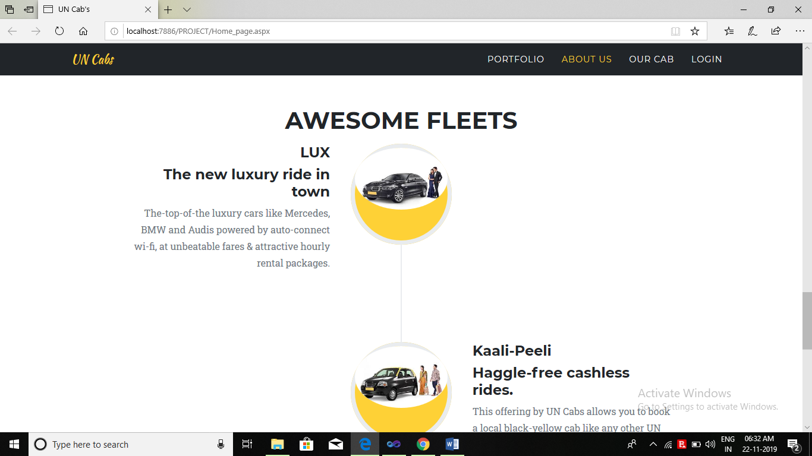



* **Responsive**

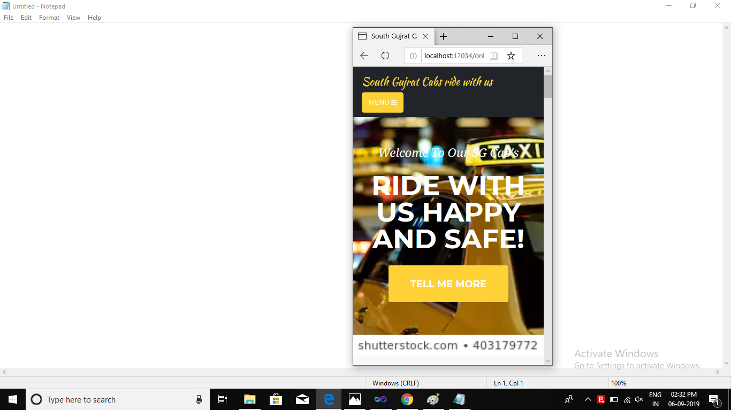

* **Admin Dashboard**

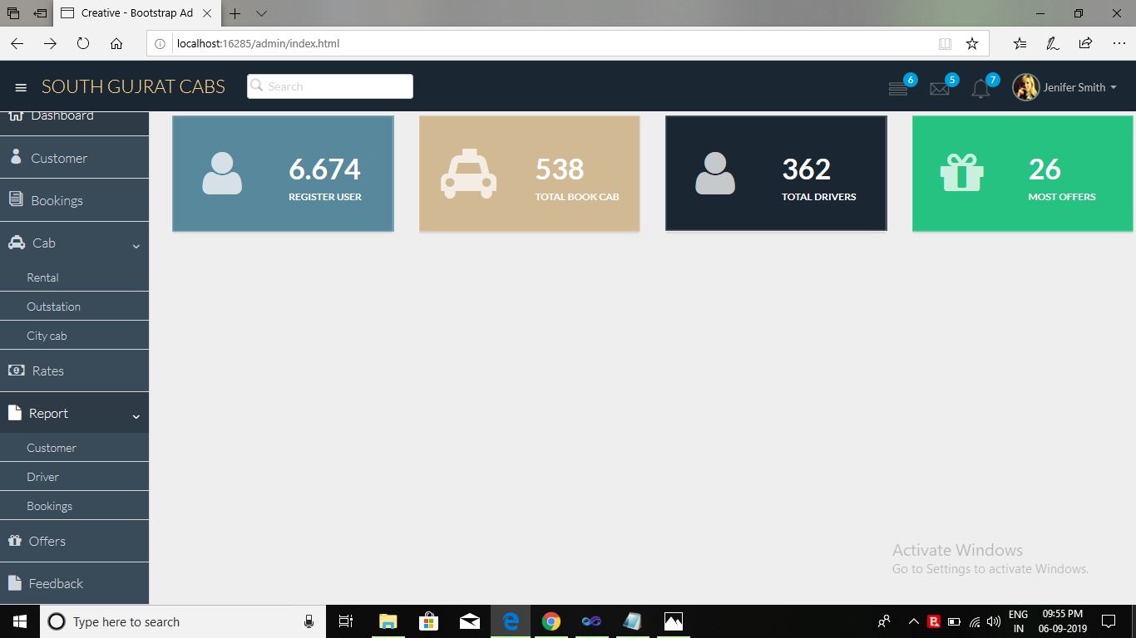

* **Customer Dashboard**

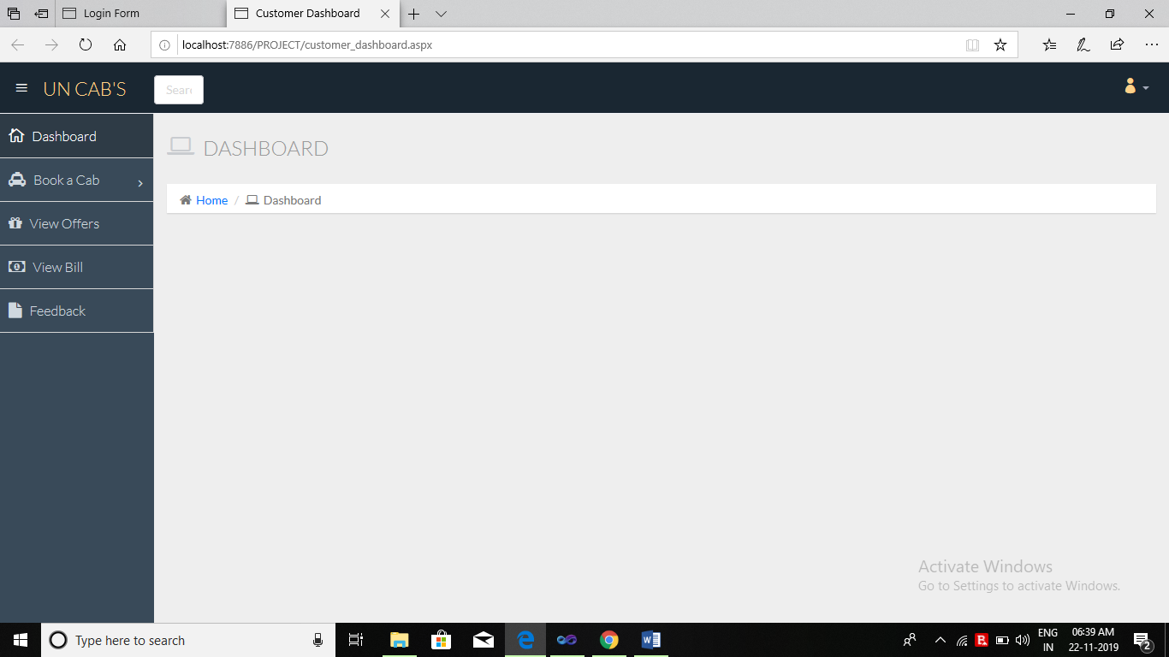

* **Driver Dashboard**

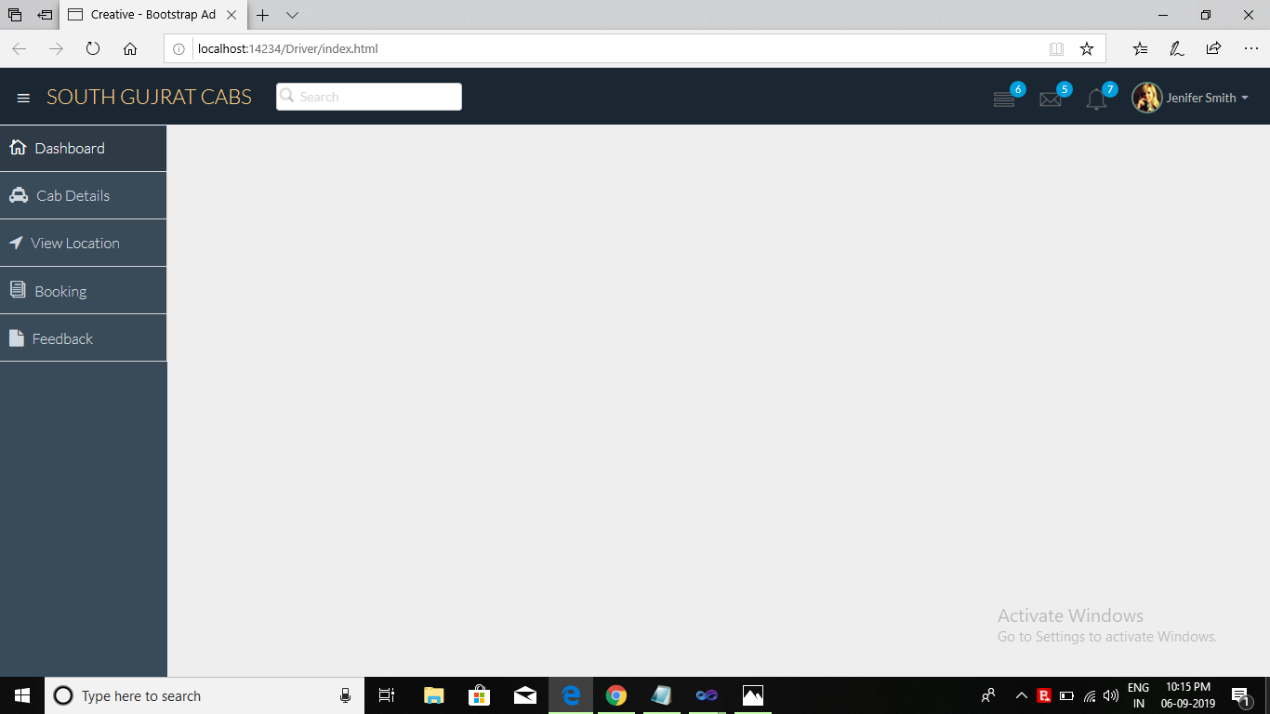

* **Login Form**

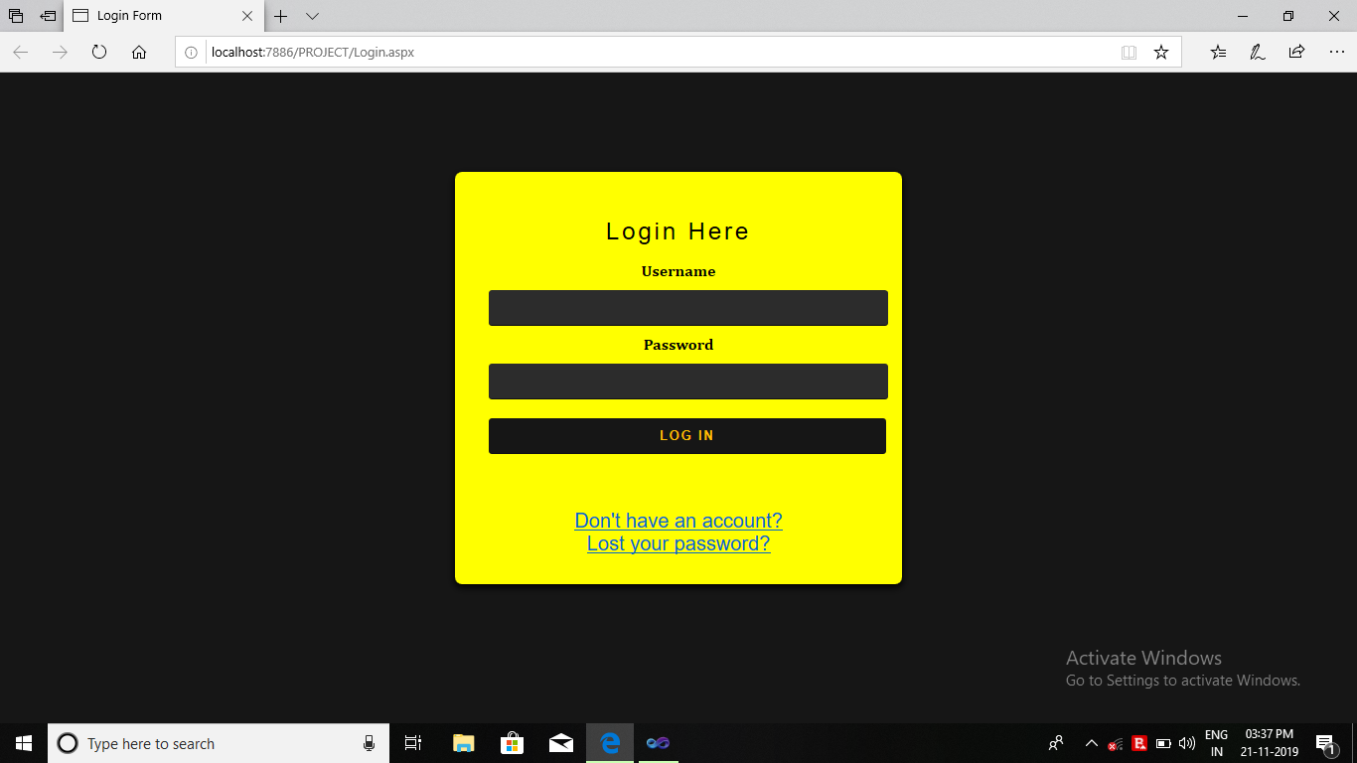

* **Registration Form**

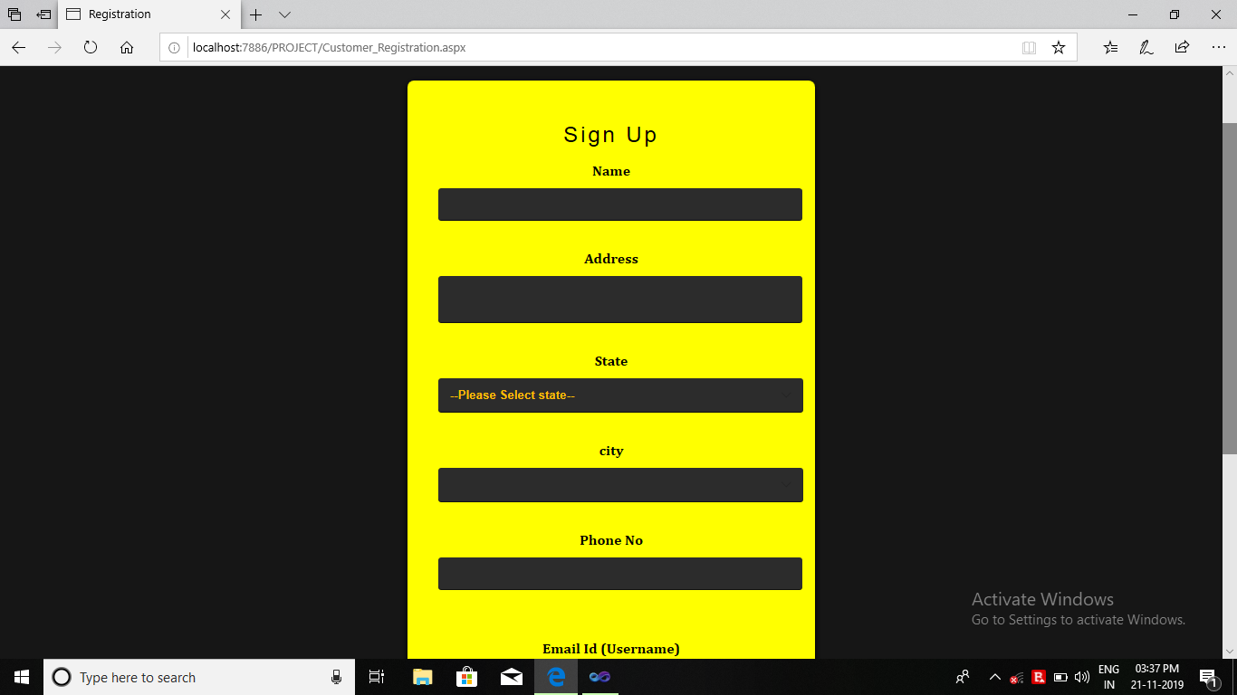

* **Book Cab**

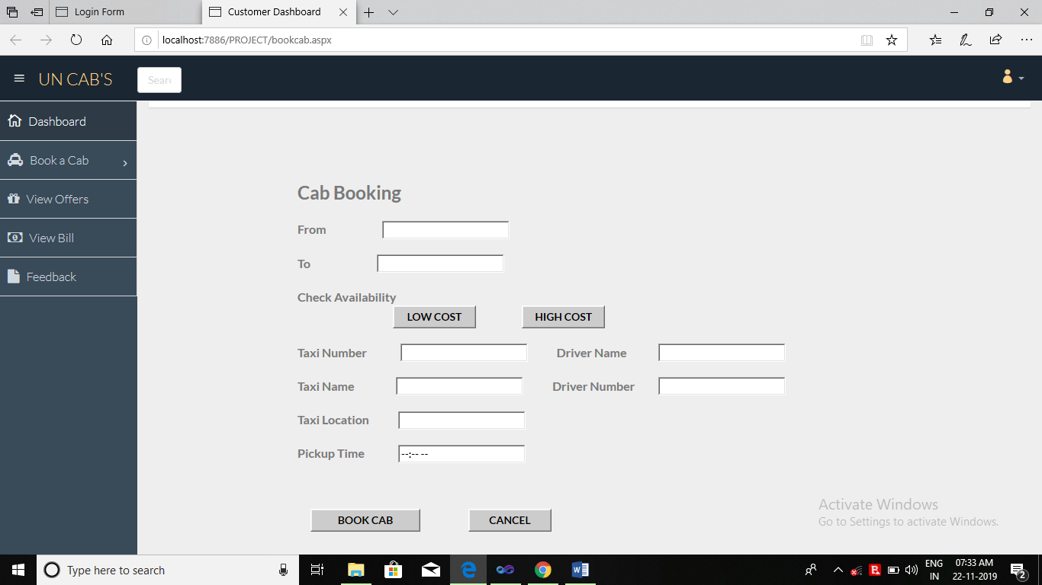

* **Thank You Page**

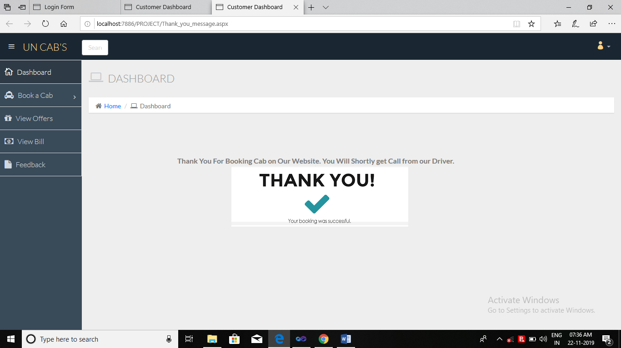

* **Forget Password**

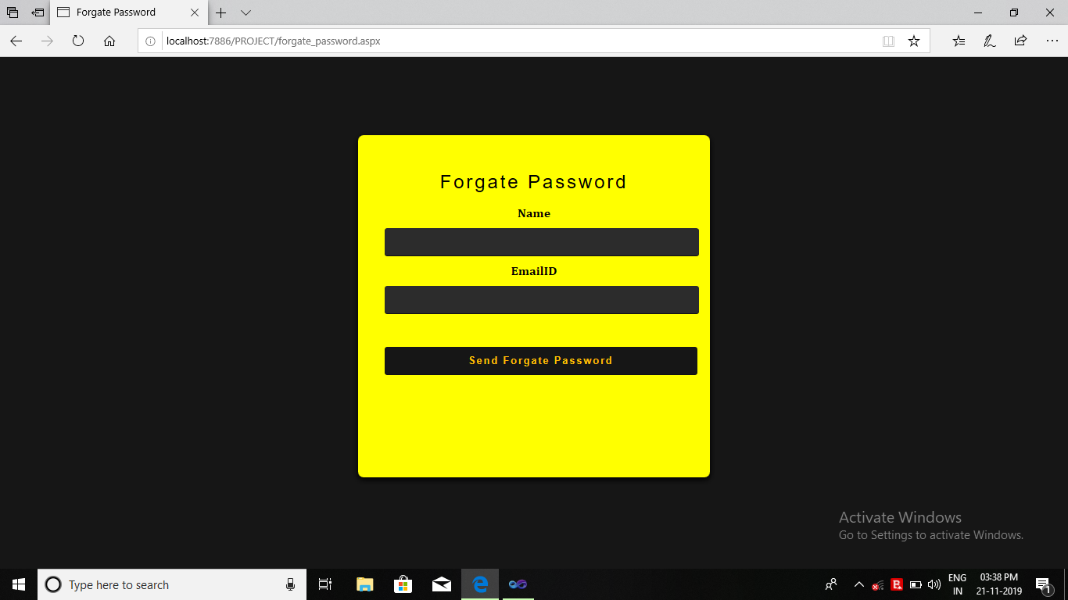

* **Offer**

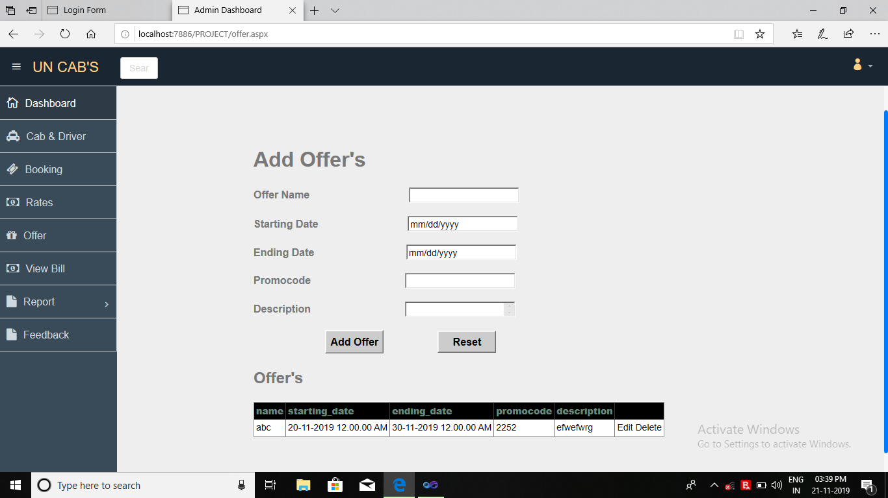

* **Add Driver Detail**

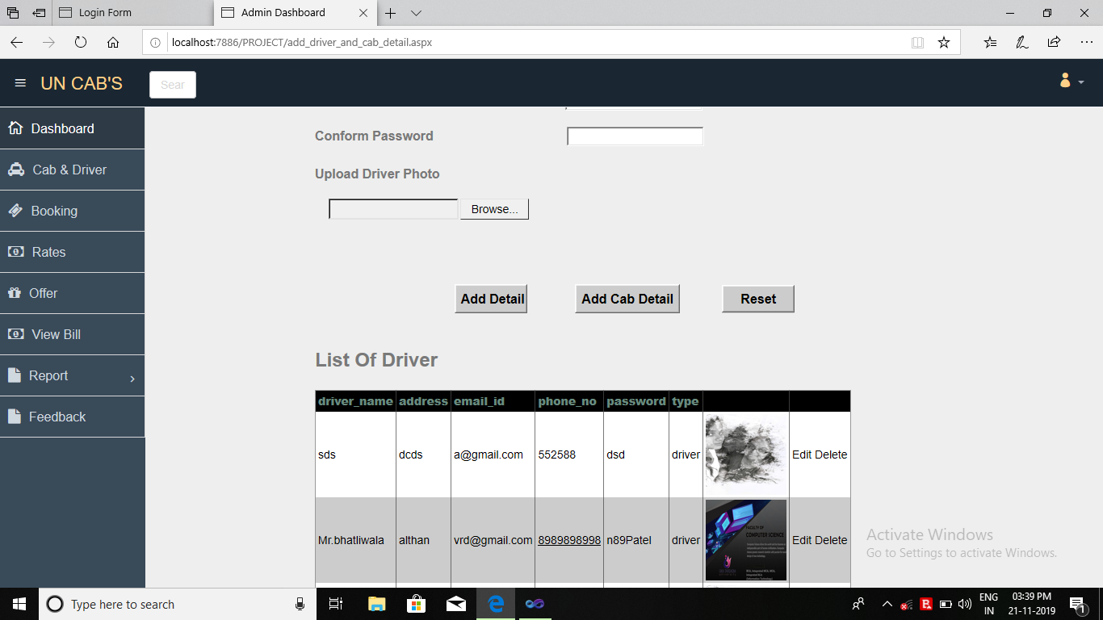

**Chapter 8: Testing**

**8.1 Test Cases**

1. **Test Case: Login**

|  |  |  |  |  |  |  |
| --- | --- | --- | --- | --- | --- | --- |
| **Test case id:** | **Components** | **Description** | **Input Values** | **Expected Output** | **Actual Output** | **Remarks** |
| CTI1 | Email | Enter email | Null | This field is required | This field is required | Fail |
|  | Email | Enter email | Invalid | Invalid input | Invalid input | Fail |
|  | Email | Enter email | [a-z,A-Z,0-9,@,,,/,_] | Accept | Accept | Pass |
| CTI 2 | Password | Enter password | Null | This field is required | This field is required | Fail |
|  | Password | All input | Not null | Accept | Accept | Pass |
| CTI 3 | Login Button | All input | Click while all or some field are invalid | Accept | Invalid Credential | Fail |
|  | Login Button | Perform event | All fields are valid | Accept | Accept | Pass |

* **2 Test Case: Registration**

|  |  |  |  |  |  |  |
| --- | --- | --- | --- | --- | --- | --- |
| Test case id: | Components | Description | Input Values | Expected Output | Actual Output | Remarks |
| CTI1 | Full Name | Enter First name | Null | This field is required | This field is required | Fail |
|  | Full Name | Enter First name | Not null | Accept | Accept | Pass |
| CTI 2 | Contact Number | Enter numeric value | Null | This field is required | This field is required | fail |
|  | Contact Number | Enter numeric value | Invalid | Invalid input | Invalid input | fail |
|  | Contact Number | Enter numeric value | [0-9] | Accept | Accept | Pass |
| CTI3 | Email | Enter email | Null | This field is required | This field is required | Fail |
|  | Email | Enter email | Invalid | Invalid input | Invalid input | Fail |
|  | Email | Enter email | [a-z,A-Z,0-9,@,,,/,_] | Accept | Accept | Pass |
| CTI 4 | Password | Enter password | Null | This field is required | This field is required | Fail |
|  | Password | All input | Not null | Accept | Accept | Pass |
| CTI6 | Address | Enter customer address | Invalid | Not Accept | Not Accept | Fail |
|  | Address | Enter customer address | valid | Accept | Accept | Pass |
| CTI 8 | Register Button | Perform event | Click while all or some field are invalid | Accept | Invalid Credential | Fail |
|  | Register Button | Perform event | All fields are valid | Accept | Accept | Pass |

* 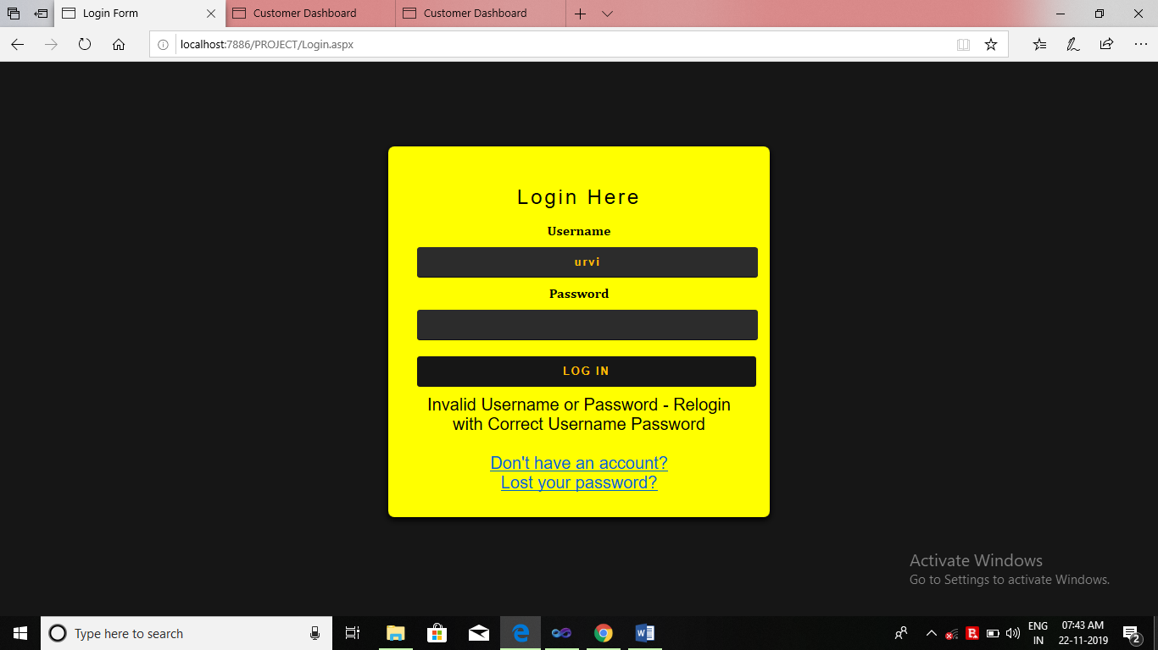**Login Test Case**
* **Attempt Locked Account**

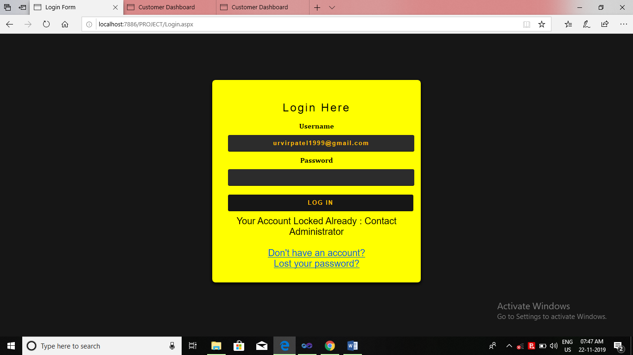

* **Registration Test Case**

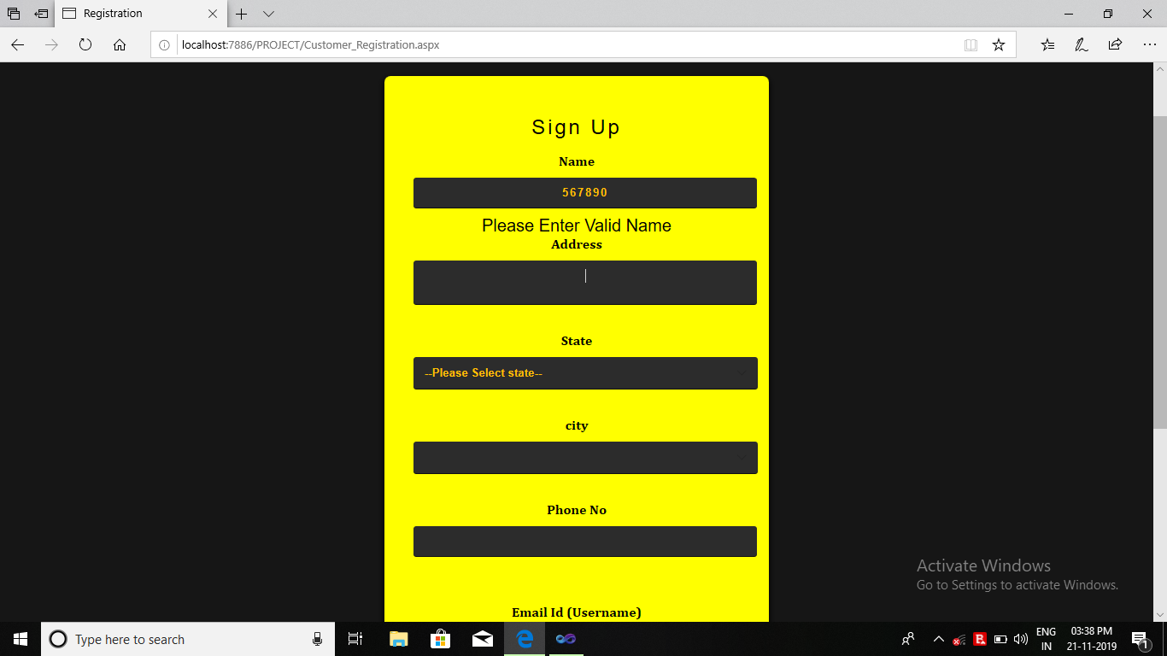

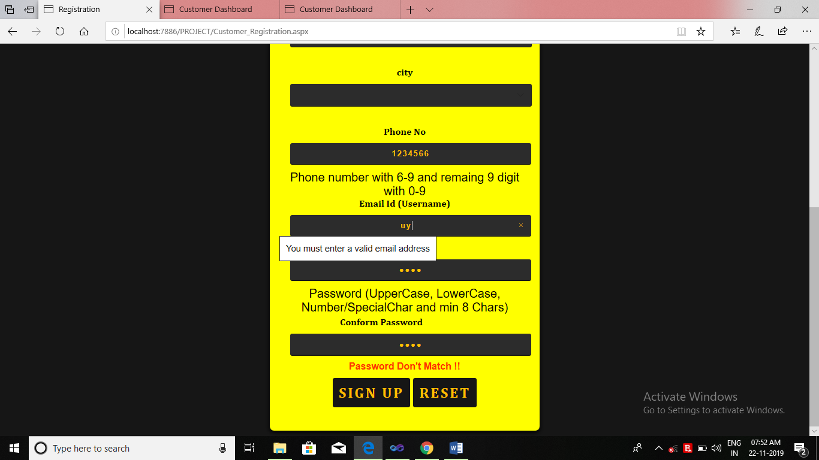

* **Send Message**

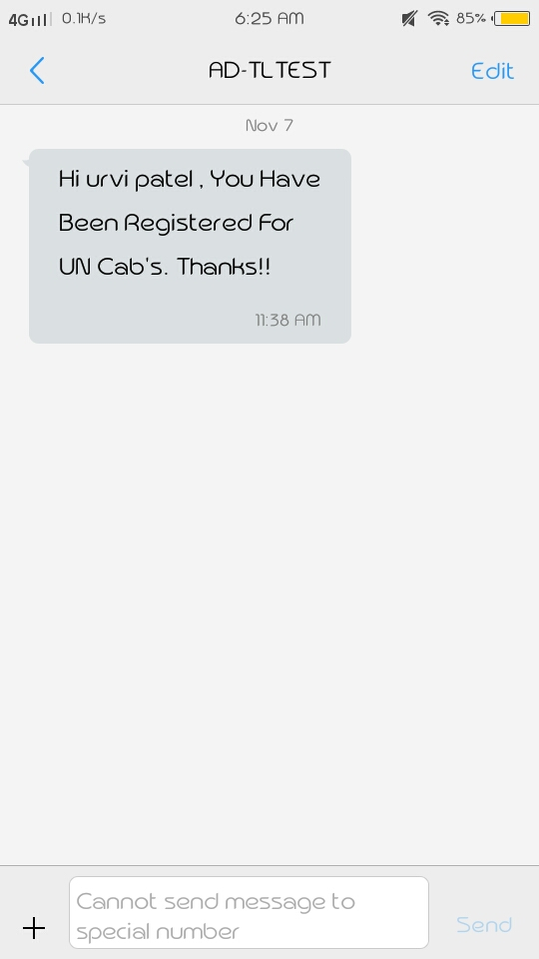

* **Send Message**
* **Send Email**

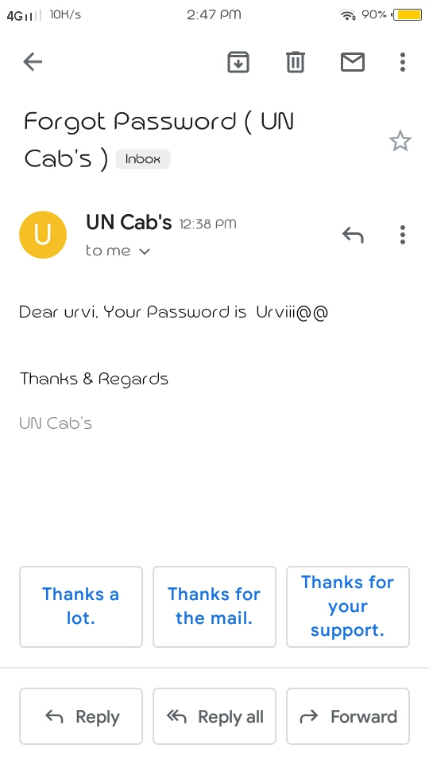

# Future Enhancements

The software can be improved in many ways and can be extended to support more devices like android applications.

# References

* [www.w3schools.com](http://www.w3schools.com/)
* csharp.net-informations.com
* [www.dotnetheaven.com](http://www.dotnetheaven.com/)
* [www.youtube.com](http://www.youtube.com/)
* Text Book (Software Engineering).